|  |  |
| --- | --- |
| Project Research  **BETA ZERO** | ABSTRACT  Birdwatching is an old practice that has a massive dedicated market. The app we are building must cater to all the watchers needs, to achieve this we had to dive deep into the Birding world.    Songo Mkondweni Lauren Sebola Neo Sedikane Derion May Lee Itumeleng Mokwena |

Table of Contents

Research 2

Introduction 2

Researched apps 2

List of best features of all apps 2

Conclusion 3

Planning & Design 4

Introduction 4

Brief Overview of application 4

Detailed list of requirements 5

User Interface design 6

Listing of data 12

Project plan 15

Conclusion 17

Reference List 18

# Research

## Introduction

To make a quality application that meets the clients needs and more, we as Beta Zero have conducted in depth research about 3 existing Birding apps. As a result, it has helped us avoid user experience pitfalls that are not so easily spotted. Understanding the strengths and weaknesses provided information mostly about user experience. From there we looked at how these apps would be implemented for android devices using Android studios. Cross-referencing the most unique features across the apps we made a list of features we may want to adopt.

## Researched apps

**Merlin Bird ID -** The main purpose of Merlin Bird ID is to answer the question “What is that bird?”, so they developed it to answer that question based on three things, sight, sound and description.

**Audubon Birds-** The Audubon Bird Guide app aims to make bird watching a fun and accessible experience to all levels of bird watchers, it helps users identify and track all the species of birds users have come across and gives them the ability to learn about other birds that are of similar nature to the ones that they might have come across and those they have yet to pass by.

**Birda -** Birda is a bird watching app that prides itself on connecting the global bird watcher’s community through their app, no matter what platform users have already recorded their findings, users can just sync their records from those other apps.

## API’s incorporated

**Merlin Bird ID –** Uses the Google Maps API.

**Audubon Birds-** Uses the Google Directions API.

**Birda –** Uses the Ebird API.

## List of best features of all apps

* **Species guide feature:** Using distribution maps and reference images, this feature assists novice birders identify unfamiliar species
* **The community:** A feature on the Birda app that allows for Bird lovers to share their own findings on a global scale.
* **“Start Bird ID” feature:** By prompting the user about the characteristics of the bird the feature presents a narrowed down list of possible matches.
* **Photo ID:** Image preprocessing. Feature extraction. The extracted features are changed into a mathematical representation and those representations are compared across other photos in the database
* **Sound ID:** This identifies the faintest of bird calls and generate a list of birds it heard.
* **“Recently spotted”:** a feature that allows for quick and easy access to a species you may see often and want to record each time.
* **Location Tracking:** A feature for pinpointing the sighting of the bird.

## Conclusion

Now that we have gathered this information, the next step is to implement the features and controls we found to be effective in the above apps. Not straying from the main objective of providing local birding hotspots with directions to those spots we chosen to adopt features like camera access to take photographs of sightings. Through connecting popular APIs like eBird data products, we will learn in real-time the best birding location.

# Planning & Design

## Introduction

**CHIRP** is a comprehensive birdwatching application designed to enhance the birdwatching experience for enthusiasts of all levels. The app offers a range of features tailored to help users track, document, and share their bird sightings with ease. From registering and managing user accounts to navigating birding hotspots with real-time map integration, CHIRP provides a seamless and intuitive interface that makes birdwatching more accessible and enjoyable. The app also includes a personal collection feature, allowing users to record and catalogue the birds they’ve spotted, as well as a species guide to assist in bird identification. Whether users are exploring their local area or traveling to new locations, CHIRP serves as a reliable companion in their birdwatching adventures.

## Brief Overview of application

We're undertaking the full-scale development of a birding app, including research, design, and coding phases. This app integrates Restful APIs, GPS, and mapping features to create an intuitive bird-watching experience. This document outlines the app's main features, its selected name, design elements with mock-ups, and a high-level overview of its functionality, all in alignment with the detailed project plan submitted earlier.

**Our Logo and App name:**



**Chirp Icon**

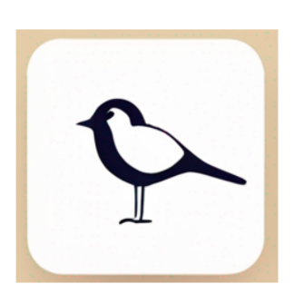

## Detailed list of requirements

1. The user must be able to register: A user must be able to enter their first name and last name as username, create a password, and save all the details to the database.
2. The user must be able to login: If the user already has a registered account, they can enter their first and last names as the username and enter the password that they created, and press log in to proceed to the homepage.
3. User must be able to change their settings: The user must be able to change their password, toggle between using the metric system and imperial system, the maximum distance that the user is willing to travel to a bird watching hotspot.
4. The user must be able to view nearby birding hotspots on a map: When the user is in their local town or is traveling to a different area, they must be able to check their map for the closest hotspots to go bird watching. Map component must be embedded in the code so that it is not easily accessible to external users.
5. The app must display hotspots filtered based on the preferred maximum distance chosen: When the user goes to settings and sets the maximum distance the map must display the hotspots within range only.
6. The app must display the user’s current position: the live location feature must be implemented to track the user and use their live location to help with other features such as finding nearby hotspots.
7. The user must be able to select a hotspot and calculate best routes: With the user being able to select a hotspot they can select a hotspot from where they are, the map will display the most efficient direction and routes to take to get to that location/hotspot from where they are.
8. The route must display visually to the user just like how the uber app shows the routes between you and your location after you have selected your destination.
9. When a user spots a bird that have just observed, they can save the location and describe, add or select from the database the bird that they have just seen. This must be stored in a database like Firebase, so a user’s data is saved.
10. The application must have a collection of all the birds the user has personally spotted so that the user can keep track of their findings.
11. We will be incorporating a species guide to assist users who entered a description of the bird narrow down what kind of bird they might have spotted.

## User Interface design

**Navigation Diagram**

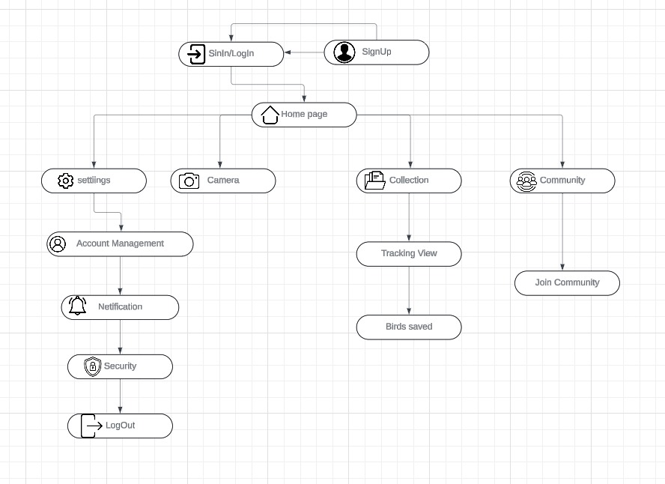

Figure 1: Nav Diagram

**Registration/Sign Up (Initial design):**

**Registration/Sign Up (Updated design):**

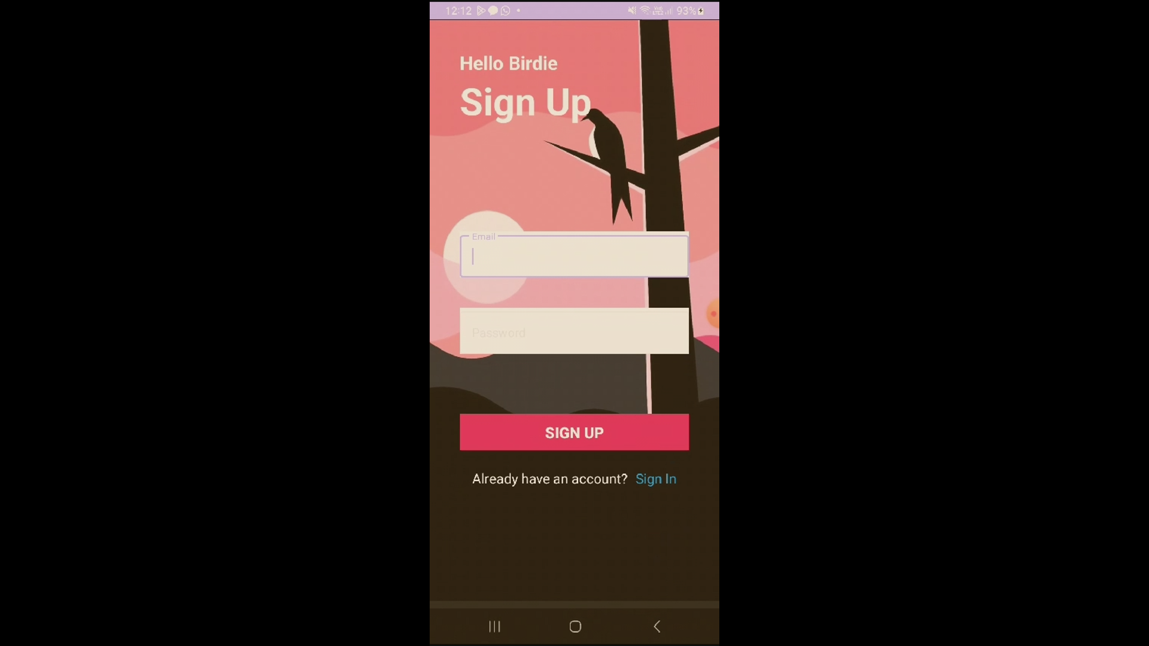

|  |
| --- |
| LOGIN/REGISTRATION |
| The Login and Registration process involves the following:  - Users provide their Email, and Password.  - During Registration, the information is stored in the Firebase database. To uphold security, passwords must be at least 8 characters long and include both letters and numbers for a stronger authentication process. |

**Initial design features:**

|  |  |
| --- | --- |
| Forgot Password | Search for Hotspots |
| - If a user forgets their password, they must enter their registered email address. This email will be checked against the database, and if it matches, a reset link will be sent to the user's email.  - After updating the password, the user will be redirected to the login page to sign in again. | -This page will use the eBird APIs to find location around that are common for Birding.  - Gps tracking to always pinpoint the user.  -  -Users can conduct a map search by either entering the name of a specific area or specifying a search radius. They can then determine the distance to the location, with the option to display it in either kilometres or miles based on their toggle selection. |

**Updated design feature:**

|  |  |
| --- | --- |
| Search for Hotspots | Add Sightings |
| -This page will use the eBird APIs to find locations around that are common for Birding.  - GPS tracking to always pinpoint the user.  -  -Users can conduct a map search by either entering the name of a specific area or specifying a search radius. They can then determine the distance to the location, with the option to display it in either kilometers or miles based on their toggle selection. | -This allows the user to add sightings of specific birds as seen in the diagram above.  - The API will take the current location of the device to add it to the database as a hotspot. |

|  |
| --- |
| Distance feature |
| -This feature allows the user to get and straight line distance from their current to location to a hotspot of their choosing.  -The distance measurements can either follow the empirial system (miles, feet) or metric system (Kilometers, metres). |

**Further updated features:**

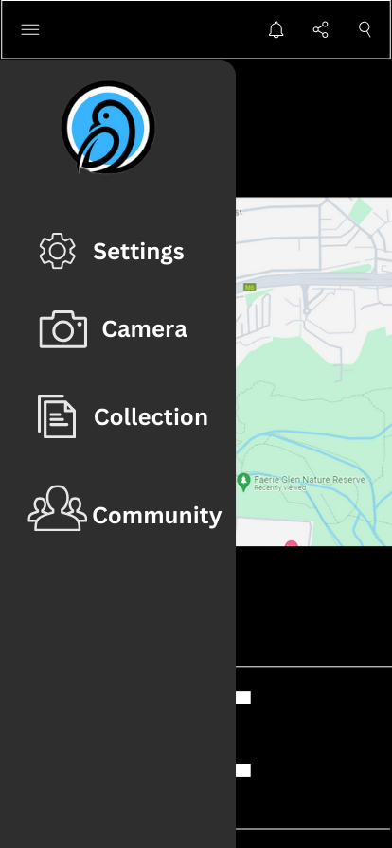 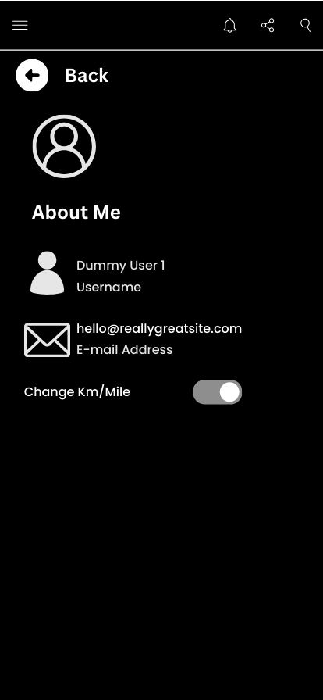

|  |  |
| --- | --- |
| Navigation menu | Account details |
| The navigation bar will feature a simple and intuitive design with four main options:  1. Settings: Allows users to customize app preferences and manage their account settings.  2. Camera: Provides quick access to the camera for capturing images or videos directly within the app.  3. Collection: Enables users to view and manage their saved items, such as photos, notes, or any collected content.  4. Community: Connects users to the community section, where they can interact with other users, share content, and participate in discussions. | The account details page will have a clean and straightforward layout, displaying only the essential user information:   * **Username:** Positioned prominently at the top of the page, the username will be displayed in bold, making it easily recognizable. * **Email:** Below the username, the user's email address will be shown in a standard font, ensuring clear visibility. |

The "Snap" option lets users view and take pictures. Alternatively, users can select a bird from the phone gallery, choose "SELECT," and be directed to the bird data entry page for the chosen image. If "DELETE" is selected, users are returned to the Phone Gallery, where they can navigate to "HOME" or other destinations using the bottom navigation bar.

|  |  |
| --- | --- |
| Camera access | List |
| The "Camera" option lets users view and take pictures. Alternatively, users can select a bird from the phone gallery, choose "SELECT," and be directed to the bird data entry page for the chosen image. If "Discard" is selected, users are returned to the Phone Gallery, where they can navigate to "HOME" or other destinations using the bottom navigation bar. | The list feature will allow users to record each bird they’ve spotted, along with a corresponding photo. For every entry, users can:  - Bird Name: Enter the name of the bird.  - Photo: Attach a picture of the bird, either taken directly via the camera or selected from the phone gallery. |

|  |
| --- |
| Blog Community |
| The blog community page will provide a space for users to share their bird sightings and records with others.  - Post Feed: A scrolling feed where users can see posts from others, each featuring the bird's name, photo, and sighting details.  - Create Post: A simple button to create and share a new post, allowing users to upload their bird record and add a caption or description. |

## Listing of data

|  |  |  |
| --- | --- | --- |
| User data stored | Data type | Reasons for the necessity of data |
| Email address | String | By using their email address, each user may be uniquely identified. It allows the app to maintain current, unique accounts and profiles and to distinguish between different users. |
| Password | String | A password keeps unauthorized users from accessing a user's account. It guarantees that their account and all of the data connected to it can only be accessed by the one who has the correct password. |
| Username | String | In case users lose track of their email addresses or have difficulties with email-based account recovery, having a username might provide an alternate means of account identification and retrieval. The username of the user adds greater personalization to their experience within the app. In order to promote a sense of familiarity and ownership, it allows the app to use the user's name or another designated identifier to show throughout the platform. |
| Bio | String | The bio allows users to personalize their profiles by sharing a bit about themselves, such as their birding experience, interests, or areas of expertise. This information helps foster a sense of community within the app, enabling users to connect with others who share similar interests or to gain insights from more experienced birders. It also adds a human element to the profile, making interactions more engaging and meaningful. |
| Picture of Bird | String | Images allow users to keep a visual log of the birds they have spotted. Those who enjoy bird watching might utilize these images as a guide to identify and comprehend the species they have observed. For people who are new to bird watching, this is very helpful in helping them recognize different species. |
| Bird name | String | By logging the bird's name, users can maintain an extensive log of their bird-watching expeditions. This helps users maintain a record of the species they have encountered over time and in different locations. Keeping the bird's name handy allows users to precisely document and remember the species they have seen. By associating the bird's name with its image and details, users are better able to remember the species and comprehend the diversity of birds. |
| Bird description | String | Some people who watch birds may not be specialists in any one bird species. Users can accurately identify a bird even if they are unable to match its physical traits, such as size, color, markings, and distinguishing features, with the help of a detailed description of the bird's physical characteristics. |
| User Location | String | Capturing the user's location (either generally or through GPS coordinates) is crucial for contextualizing bird sightings. Birds are often tied to specific habitats and regions, so knowing the location where a bird was spotted is essential for accurate identification and for contributing to citizen science data. Additionally, location data can help the app suggest nearby birding hotspots, track regional bird migration patterns, and connect users with local birding communities or events. It also allows for filtering and searching sightings based on geographic areas, enhancing the app's usability and relevance. |
| Measuring system (Imperial/ Metric) | String | They will not have to constantly switch between different measuring systems every time they use the app because their settings are stored. It provides a streamlined, consistent, and preferences-tailored experience. Individuals using the application may originate from different parts of the globe where either the metric or imperial systems are commonly employed. It ensures inclusivity and meets the needs of users regardless of their preferred unit of measurement by offering both options. |
| Bird ID | String | A unique Bird ID is essential for identifying and differentiating each bird entry within the app's database. It allows for efficient retrieval, updating, and deletion of specific records without confusion or duplication. |
| Scientific Name | String | The scientific name provides a universal way to identify bird species, regardless of regional language differences. It is crucial for accuracy, especially for users or researchers who are familiar with taxonomy and need precise identification. |
| Date and Time Spotted | DateTime | Capturing the date and time of spotting allows users to document and track their birding activities over time. This information is valuable for understanding bird migration patterns, seasonal behaviors, and for maintaining a personal record of sightings. |
| Photo/Video | String | Photos and videos provide visual evidence of the bird sighting, enhancing the user's experience and the authenticity of the record. They also allow for easier verification of species by other users or experts, and they enrich the content shared within the app. |
| Notes/ Comments | String | Notes or comments offer a space for users to record additional observations, such as behavior, habitat, or unusual features. This qualitative data adds depth to the sighting and can be useful for personal reference or sharing insights with the community. |
| Birds Spotted | Integer | Tracking the total number of birds spotted by a user is important for monitoring their activity and engagement with the app. It provides a sense of progress and achievement, encouraging continued use and fostering a competitive or goal-oriented atmosphere among users. |
| Species Identified | Integer | Recording the number of unique species identified by a user helps measure their birding expertise and exposure to different species. This metric can be used to unlock achievements, suggest new challenges, or compare progress with other users. |
| Badges/Achievements | String | Badges and achievements are motivational tools that reward users for their activity and milestones within the app. They enhance user engagement by providing recognition and a sense of accomplishment, encouraging users to explore more features and continue their birding journey. |

## Project plan

## Conclusion

CHIRP is designed to be the ultimate tool for birdwatchers, combining advanced technology with user-friendly features to create a unique and interactive birdwatching experience. By offering features like customizable settings, real-time map integration, and a community sharing platform, CHIRP not only helps users track their sightings but also connects them with a larger community of bird enthusiasts. The app’s ability to store and organize sightings in a personal collection ensures that users can keep track of their findings over time, while the species guide assists in accurate identification. With CHIRP, birdwatchers can explore, document, and share their love for birdwatching in a way that is both convenient and engaging.

**AI Generator Writeup**

In developing a comprehensive birding application, I utilized an AI language model to assist with refining project documentation. The tool was particularly effective in helping to simplify content, ensuring clarity and cohesion in the project overview. This allowed for more polished communication of the project's objectives, features, and design elements, which are crucial for effective team collaboration and stakeholder presentation.

## Reference List

Audubon Society (n.d.). *Audubon Bird Guide App*. [online] Audubon. Available at: <https://www.audubon.org/app>.

BIRDA (2022). *Free Birdwatching App To Connect With Nature | Birda*. [online] birda.org. Available at: <https://birda.org/> [Accessed 23 Aug. 2024].

Byington, C. (2013). *Boucher’s Birding Blog: Apps for the Smart Birder — Which One Should You Use?* [online] Cool Green Science. Available at: <https://blog.nature.org/2013/05/27/boucher-bird-blog-apps-smart-birder/> [Accessed 22 Aug. 2024].

Cornell Lab of Ornithology (2019). *eBird - Discover a new world of birding...* [online] Ebird.org. Available at: <https://ebird.org/home> [Accessed 15 Aug. 2024].

Merlin Bird ID (2019). *Merlin Bird ID – Free, instant bird ID help for 4,500+ birds*. [online] Allaboutbirds.org. Available at: <https://merlin.allaboutbirds.org/>

University, C. (2015). *eBird*. [online] App Store. Available at: <https://apps.apple.com/us/app/ebird/id988799279> [Accessed 15 Aug. 2024].

OpenAI. (2024). *ChatGPT*. Available at: <https://www.openai.com/chatgpt> (Accessed: 22 August 2024).